RAJA BALWANT SINGH ENGINEERING TECHNICAL CAMPUS
BICHPURI, AGRA

FACULTY OF PHARMACY

“World Pharmacist’s Day Celebration”
(20-Sep-2019)

An event was organized in faculty of pharmacy to “celebrate world pharmacist’s Day” on Sep-20-2019 at 12:30 P.M.

EVENT PROCEEDINGS:-
An event was held in faculty of pharmacy to celebrate “World Pharmacist’s day”.
- Inauguration of the event was done by honorable Dr. B.S Kushwah (DIRECTOR, RBSETC, Bichpuri) followed by ribbon cutting and sapling. After this he gave a fruitful speech in which he acknowledged the importance of medical sciences in life. Also told about the importance of the meditation in our life. “A healthy brain lies in a healthy body” with this phrase he described his views.

- Dr. Nitin Agrawal (HOD of faculty of pharmacy) gave his delightful speech with respect of day and gave greets of day. He enlighten us with elaborating the phrase said by our respected director sir “A HEALTHY BRAIN LIES IN HEALTHY BODY” .He also explained the importance of meditation in our lives and asked to adapt into our lifestyle.

- TEACHERS (FACULTY OF PHARMACY, RBSETC, Bichpuri)
Tanya Gupta, RBSETC, Bichpuri of “AROGYAM” gave the start up to the sessions and with permission of all dignitaries started the program , in which the society members were asked to manage the coordination . Faculty teachers expressed their feelings of the day with their words. All the teachers gave their blessings to the students.

Students of the pharmacy organized the health checkup camp for teaching and non-teaching staff of RBSETC and got 16 entries.

PHOTOGRAPS
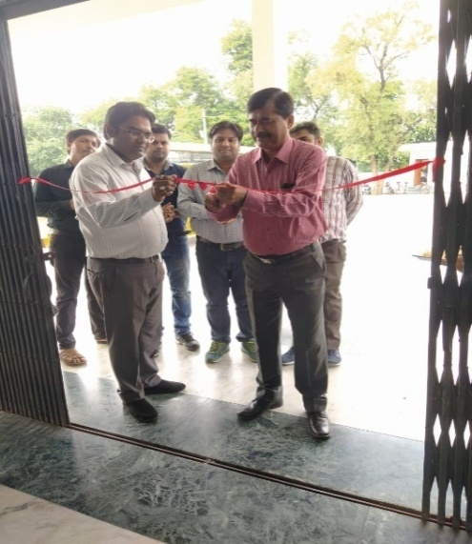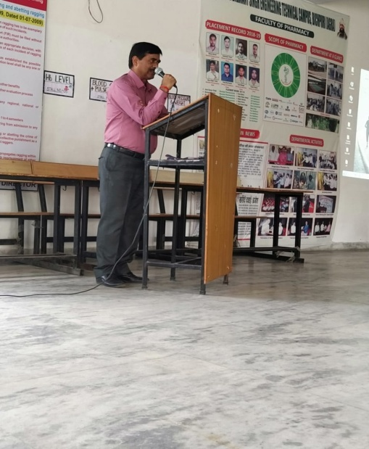
Inauguration Dr. B.S KUSHWAH (DIRECTOR RBSETC, Bichpuri)

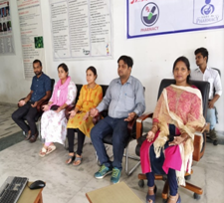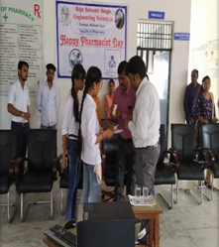
Facultyof Pharmacy Sapling

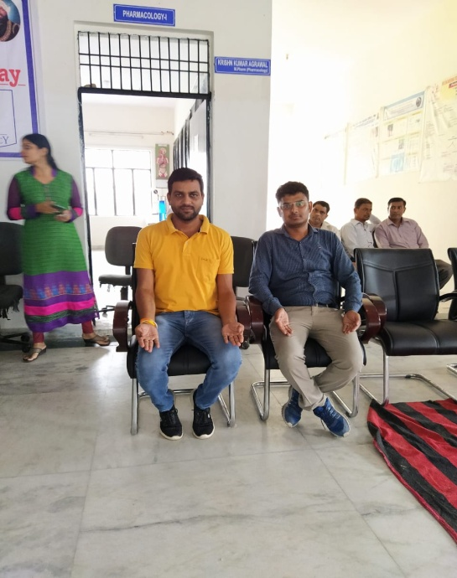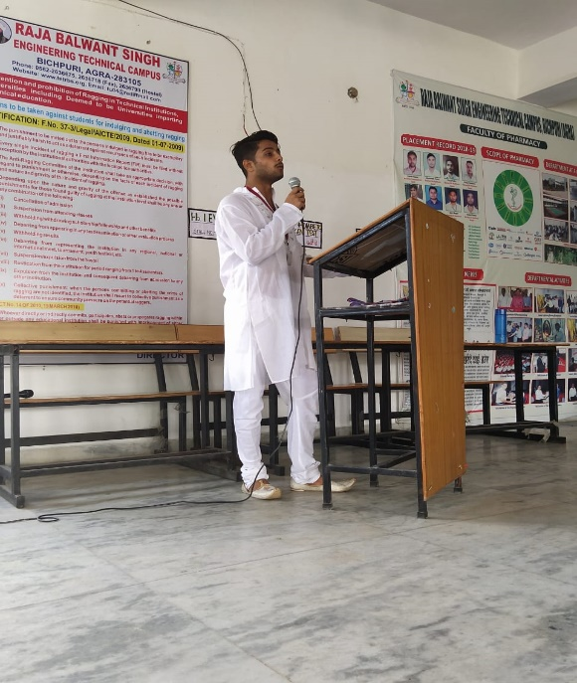
Faculty of Engineering Meditation

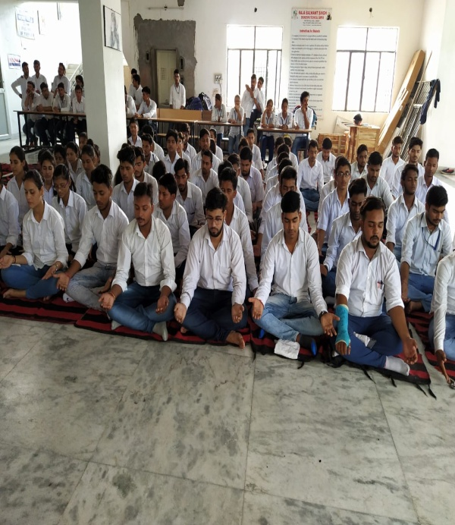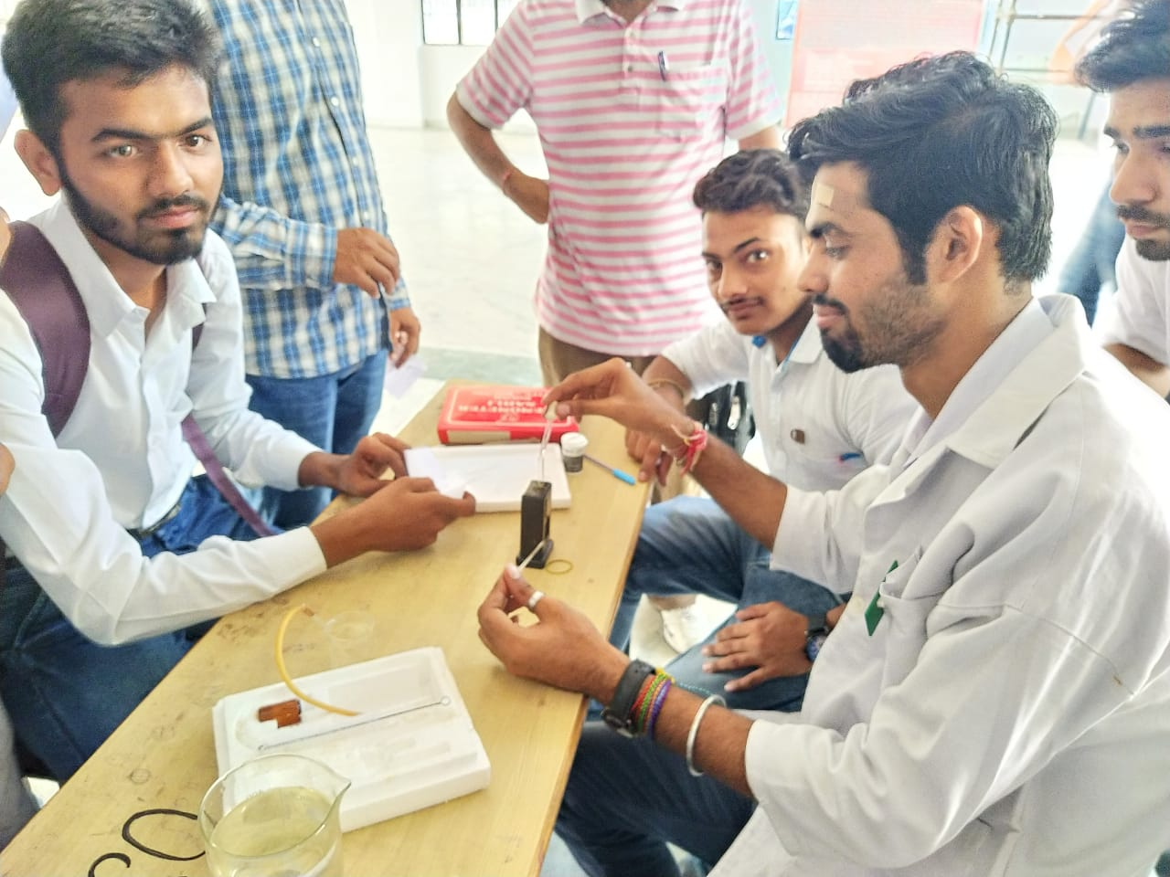
Meditation Section Health Checkup Camp

